Comp 4322 Internetworking Protocols, Software and Management
Lab 3: IP & ICMP

Student Name: Cheng Wui Sum
Student ID: 22074221d
Due: 11:59pm, April 8, 2026

IP

Q3
How many bytes are in the IP header? How many bytes are in the payload of the IP datagram? Explain how you determined the number of payload bytes.
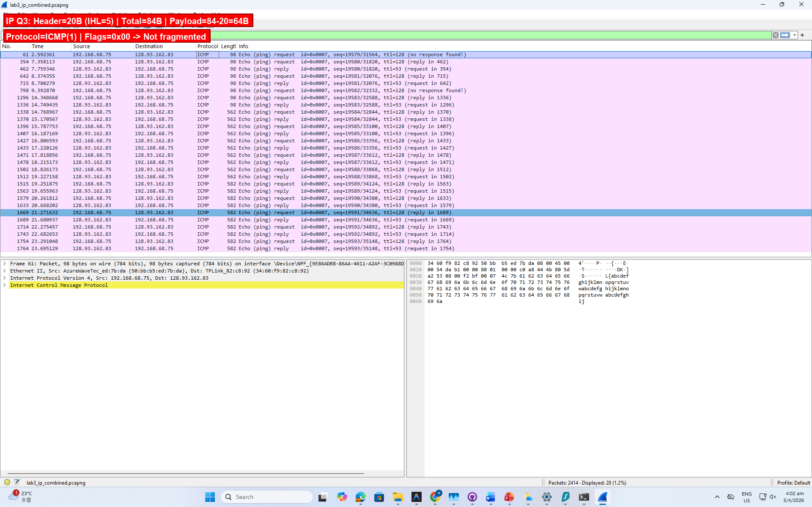
The IP header is 20 bytes long, indicated by the Header Length field: IHL = 5 (5 × 4 = 20 bytes). The IP payload is 64 bytes, calculated as: Total Length (84) − Header Length (20) = 64 bytes. The 64-byte payload consists of the 8-byte ICMP header (Type, Code, Checksum, Identifier, Sequence Number) plus 56 bytes of ICMP data ("abcdefghijklmnop..." padding).

Q5
Which fields in the IP datagram always change from one datagram to the next within this series of ICMP messages sent by your computer?
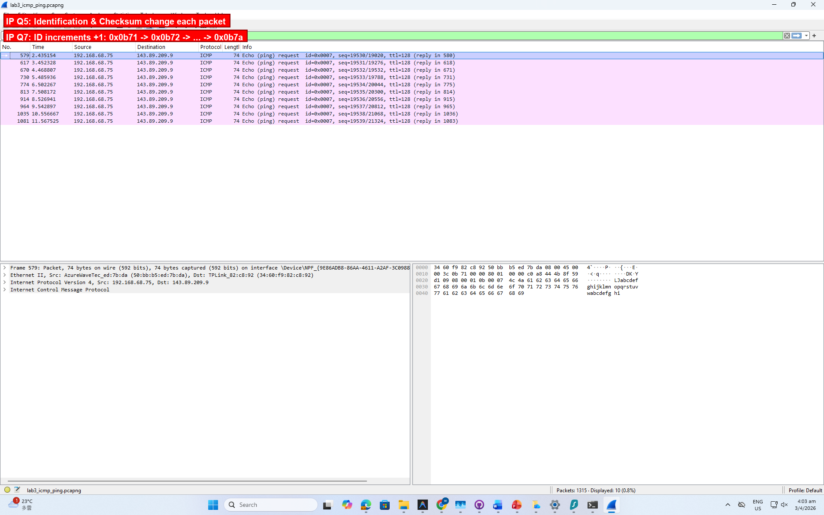
The fields that always change are:
1. Identification — increments by 1 each packet (0x0b71, 0x0b72, 0x0b73, ..., 0x0b7a)
2. Header Checksum — recomputed for each datagram since the Identification field changed
Fields that stay constant: Version (4), Header Length (20), DSCP (0x00), Total Length (60), Flags (0x00), Fragment Offset (0), TTL (128), Protocol (ICMP/1), Source IP (192.168.68.75), Destination IP (143.89.209.9). The constant fields must stay the same because they describe the same type of packet to the same destination. The Identification and Checksum must change because each datagram needs a unique ID for reassembly, and the checksum covers the header.

Q7
Describe the pattern you see in the values in the Identification field of the IP datagram.
As shown in the screenshot above, the Identification field increments sequentially by exactly 1 for each successive ICMP Echo Request: 0x0b71 (2929), 0x0b72 (2930), 0x0b73 (2931), ..., 0x0b7a (2938). This is the standard behavior of the Windows IP stack, which uses a simple incrementing global counter for the Identification field.

Q9
Do these values remain unchanged for all of the ICMP TTL-exceeded replies sent to your computer by the nearest (first hop) router? Why?
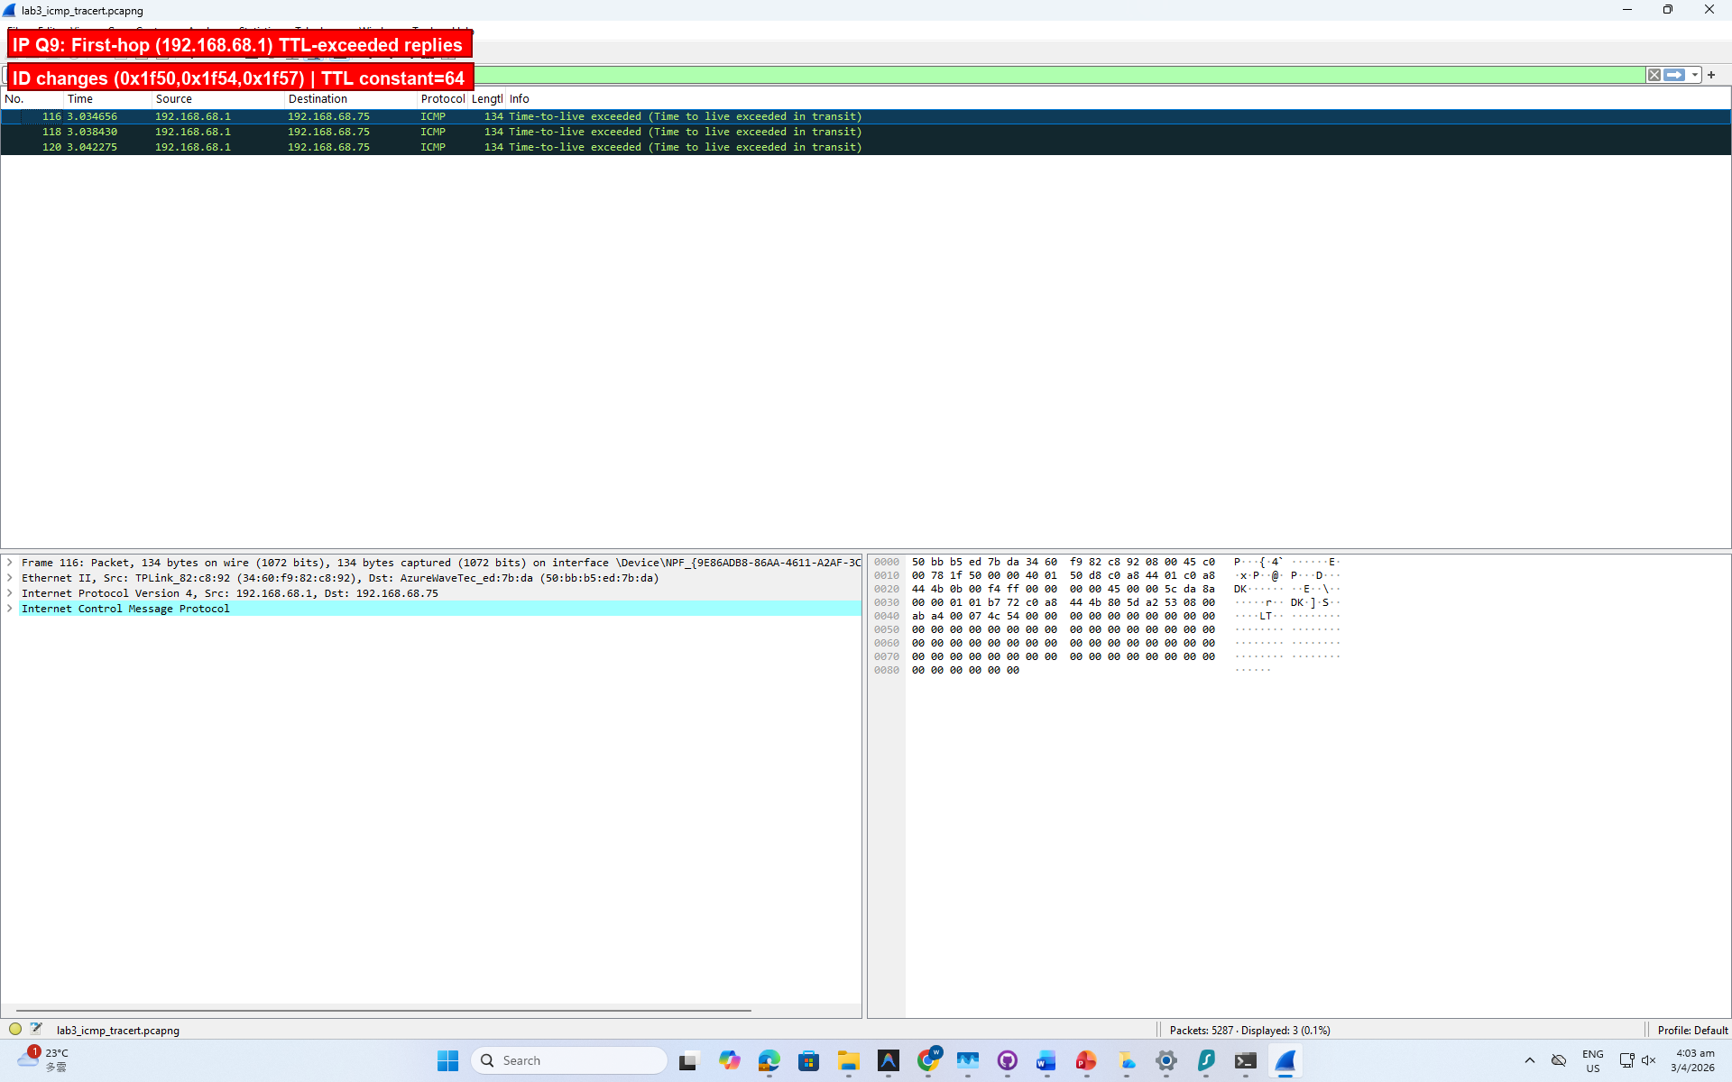
The three TTL-exceeded replies from the first-hop router (192.168.68.1) show:
• TTL: constant at 64 for all three replies. This is expected — the router is one hop away and uses a default TTL of 64.
• Identification: changes between replies (0x1f50, 0x1f54, 0x1f57). This is expected because each ICMP TTL-exceeded reply is a new IP datagram generated by the router with its own incrementing Identification counter. The values are not strictly sequential because the router sends other IP datagrams between these replies.

Q11
Print out the first fragment of the fragmented IP datagram. What information in the IP header indicates that the datagram has been fragmented? What information in the IP header indicates whether this is the first fragment versus a latter fragment? How long is this IP datagram?
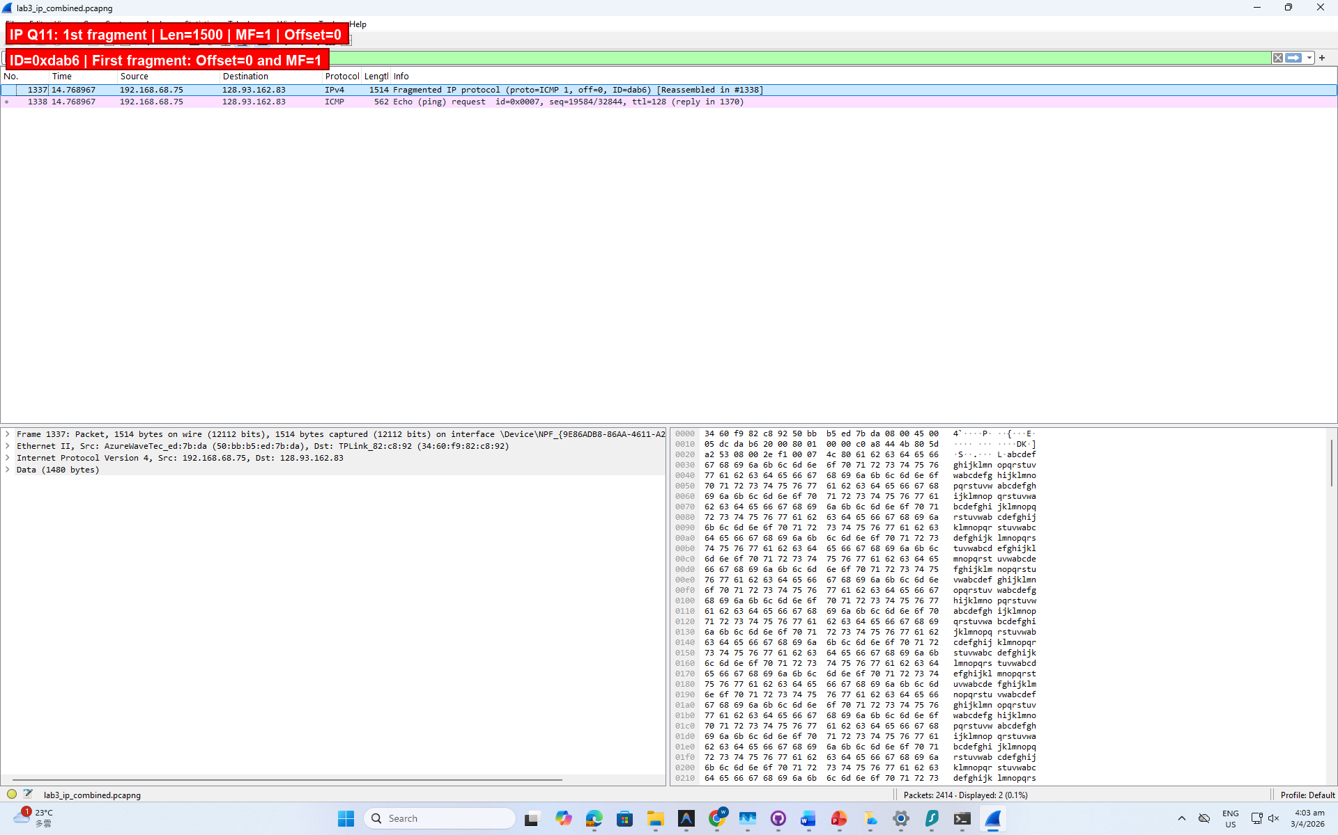
First fragment (Frame 1337) of the 2000-byte ICMP Echo Request:
• Total Length: 1500 bytes
• Identification: 0xdab6
• Flags: More Fragments (MF) = 1 — this indicates the datagram HAS been fragmented.
• Fragment Offset: 0 — this indicates it is the FIRST fragment.
How to distinguish first vs. latter fragments:
• First fragment: MF = 1, Offset = 0
• Latter fragment: Offset > 0 (MF = 1 if more follow, MF = 0 if last)
This IP datagram is 1500 bytes long (maximum Ethernet MTU).
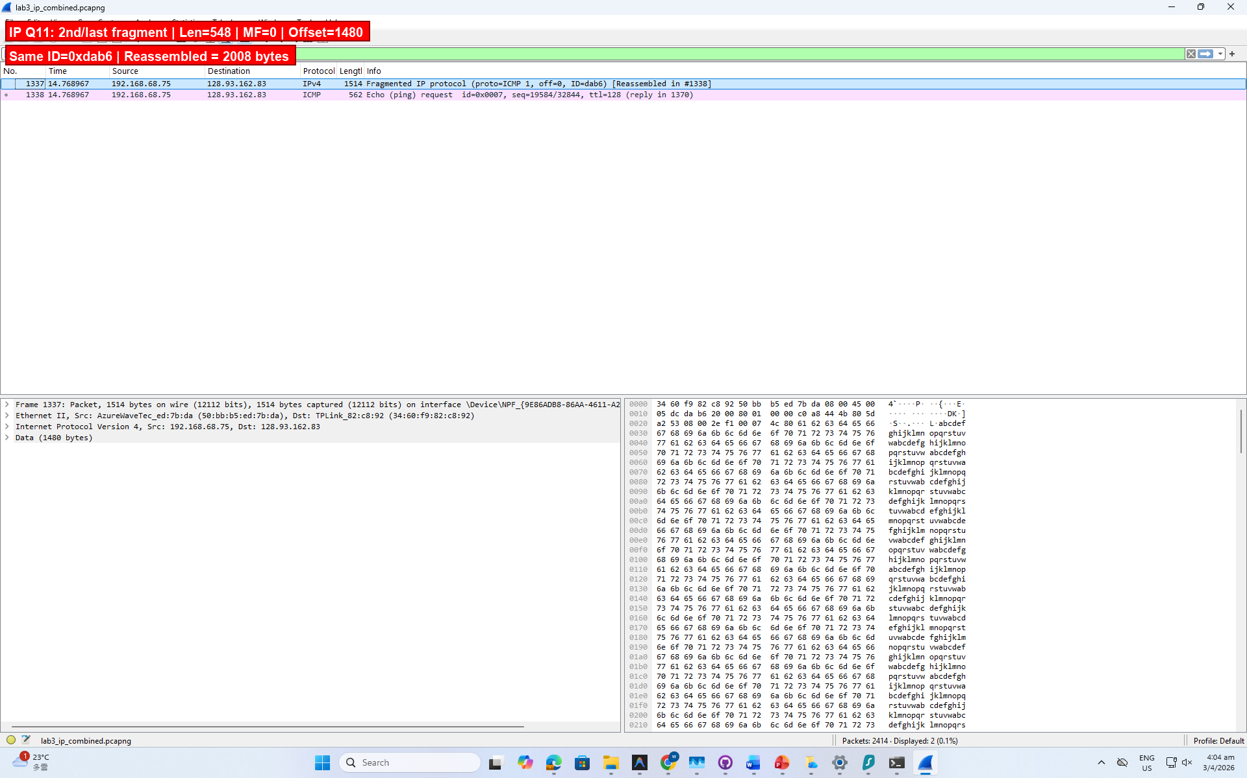
Second/last fragment (Frame 1338):
• Total Length: 548 bytes, MF = 0 (no more fragments), Offset = 1480
• Same Identification 0xdab6 confirms it belongs to the same original datagram.
• Offset > 0 indicates this is NOT the first fragment. MF = 0 indicates it is the last.
• Reassembled total: 1480 + 528 = 2008 bytes (20 IP header + 8 ICMP header + 2000 data - 20 = 2008 payload).

Q15
What fields change in the IP header among the fragments?
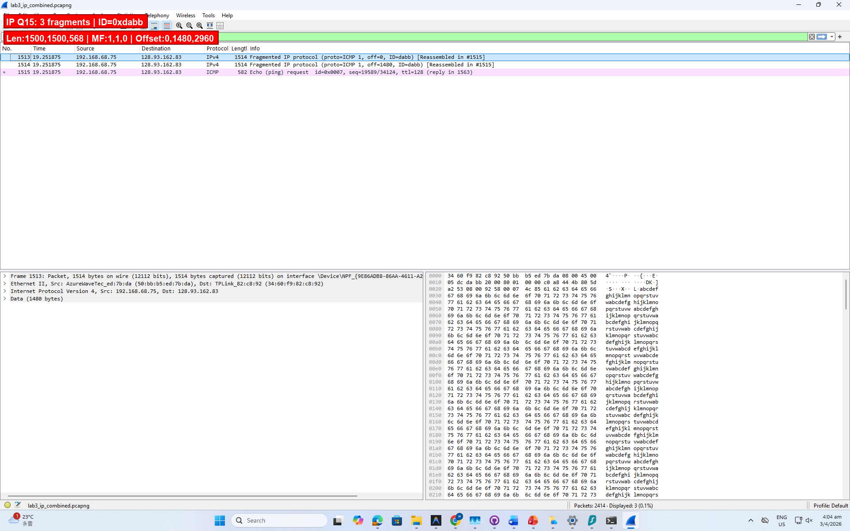
The 3500-byte ICMP Echo Request is fragmented into 3 IP datagrams (ID = 0xdabb):
Fragment 1: Total Length = 1500, MF = 1, Offset = 0
Fragment 2: Total Length = 1500, MF = 1, Offset = 1480
Fragment 3: Total Length = 568, MF = 0, Offset = 2960
Fields that CHANGE among fragments:
1. Total Length — 1500, 1500, 568
2. More Fragments (MF) flag — 1, 1, 0
3. Fragment Offset — 0, 1480, 2960
4. Header Checksum — recomputed for each fragment
Fields that stay the SAME: Version, IHL, DSCP, Identification (0xdabb), TTL (128), Protocol (ICMP/1), Source IP, Destination IP. The Identification must stay the same so the receiver can reassemble the fragments.

ICMP

Q1
What is the IP address of your host? What is the IP address of the destination host?
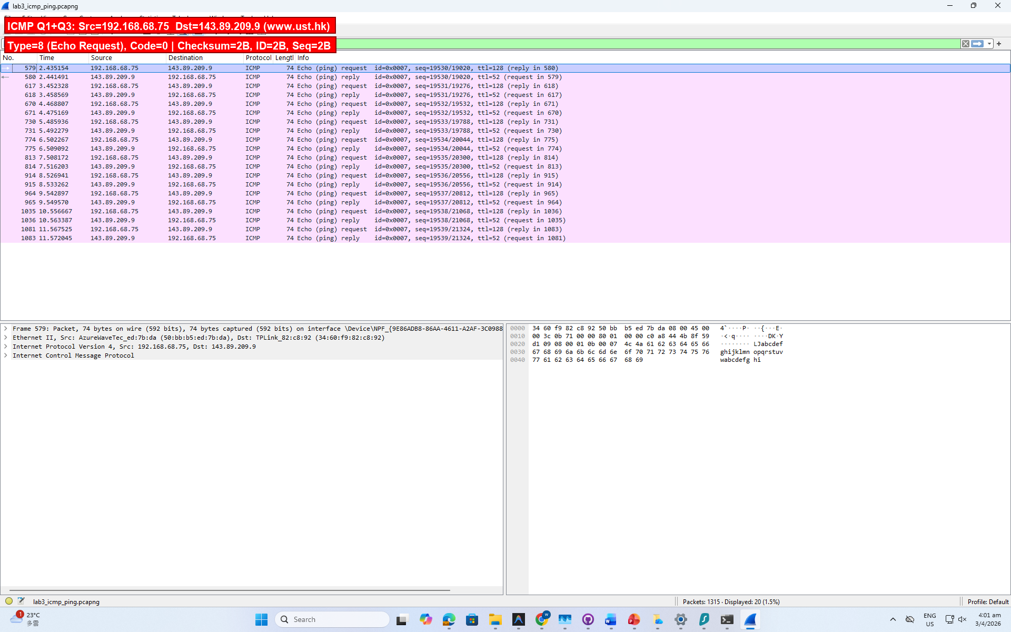
From the first ICMP Echo Request (Frame 579) in the ping capture:
• My host IP address: 192.168.68.75
• Destination host IP address: 143.89.209.9 (www.ust.hk)
My host uses a private IP address (192.168.68.0/22 subnet) behind a NAT router (TP-Link, 192.168.68.1).

Q3
Examine one of the ping request packets sent by your host. What are the ICMP type and code numbers? What other fields does this ICMP packet have? How many bytes are the checksum, sequence number and identifier fields?
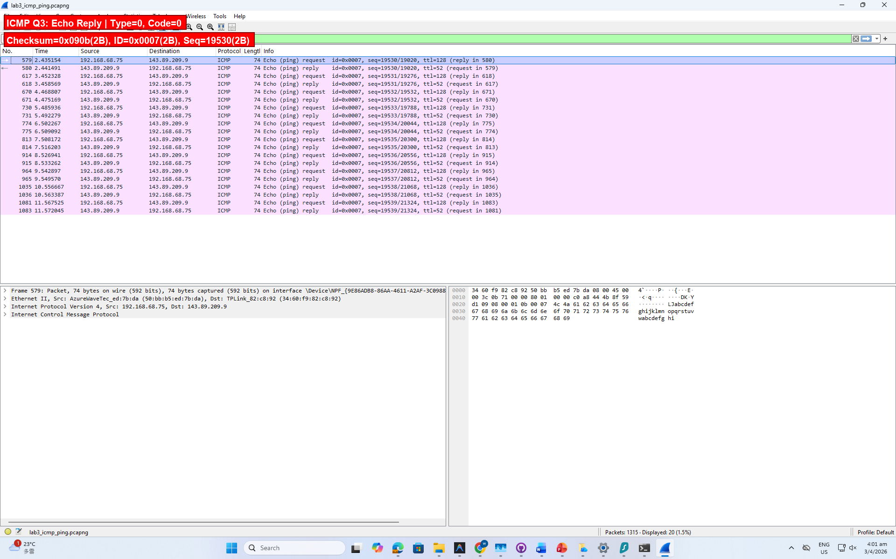
Ping Echo Request (Frame 579):
• Type: 8 (Echo Request)
• Code: 0
Other fields:
• Checksum: 0x010b — 2 bytes (16 bits)
• Identifier: 0x0007 — 2 bytes (16 bits)
• Sequence Number: 19530 (0x4c4a) — 2 bytes (16 bits)
• Data: 32 bytes of padding ("abcdefghijklmnop...")
Corresponding Echo Reply (Frame 580):
• Type: 0 (Echo Reply), Code: 0
• Checksum: 0x090b (2 bytes), Identifier: 0x0007 (2 bytes), Sequence: 19530 (2 bytes)
• The reply contains the same Identifier, Sequence Number, and Data as the request.

Q7
Examine the ICMP echo packet in your screenshot. Is this different from the ICMP ping query packets in the first half of this lab? If yes, how so?
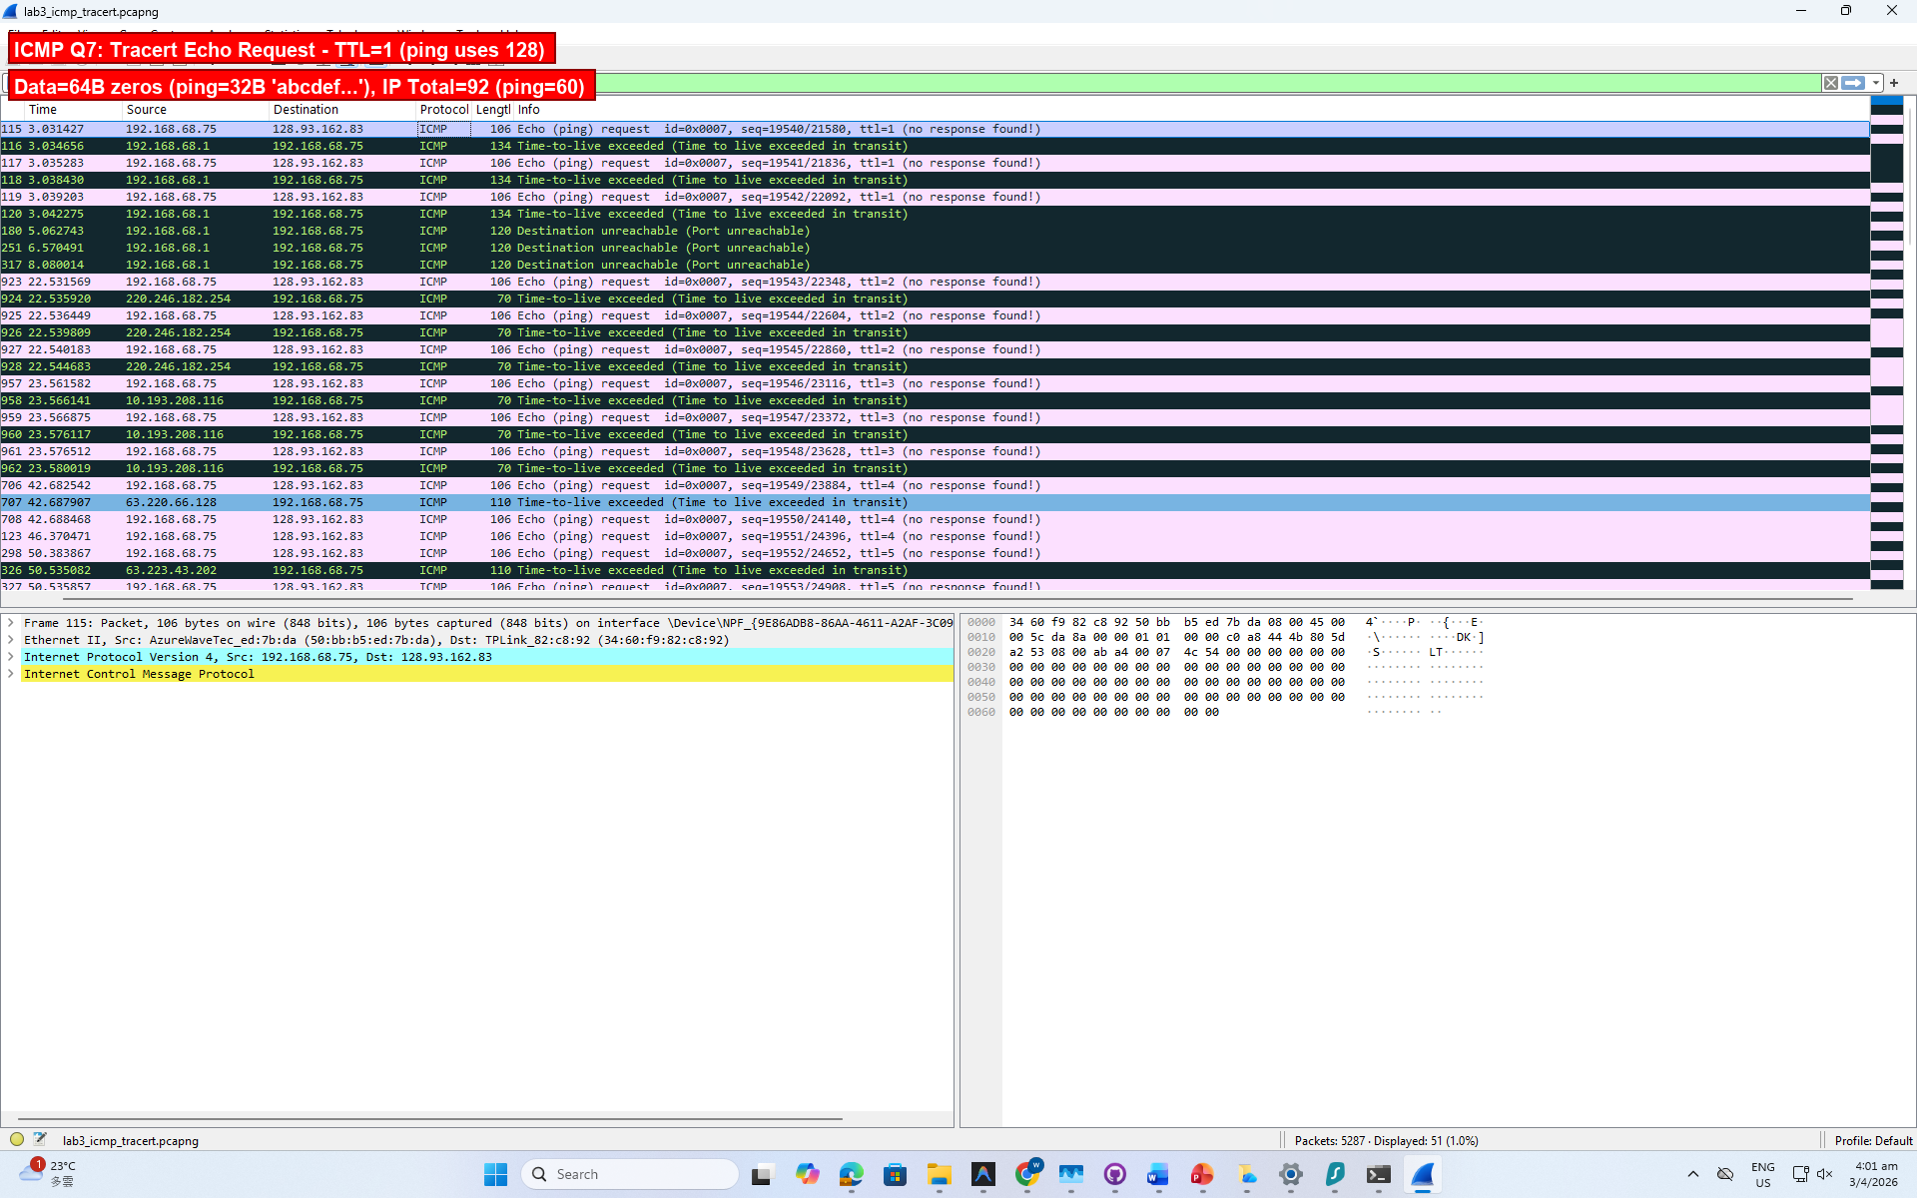
The tracert ICMP Echo Request (Frame 115) differs from the ping Echo Request:
1. TTL: Tracert sets TTL = 1 (incrementing per hop), while ping uses TTL = 128 (Windows default). This is the fundamental difference — tracert uses low TTL values to discover intermediate routers.
2. Data size: Tracert carries 64 bytes of all-zero padding; ping carries 32 bytes of "abcdefgh..." padding.
3. IP Total Length: Tracert = 92 bytes (20 IP + 8 ICMP + 64 data); Ping = 60 bytes (20 + 8 + 32).
Similarities: Both use Type 8 (Echo Request), Code 0, and have the same ICMP fields (Checksum, Identifier, Sequence Number).

Q9
Examine the last three ICMP packets received by the source host. How are these packets different from the ICMP error packets? Why are they different?
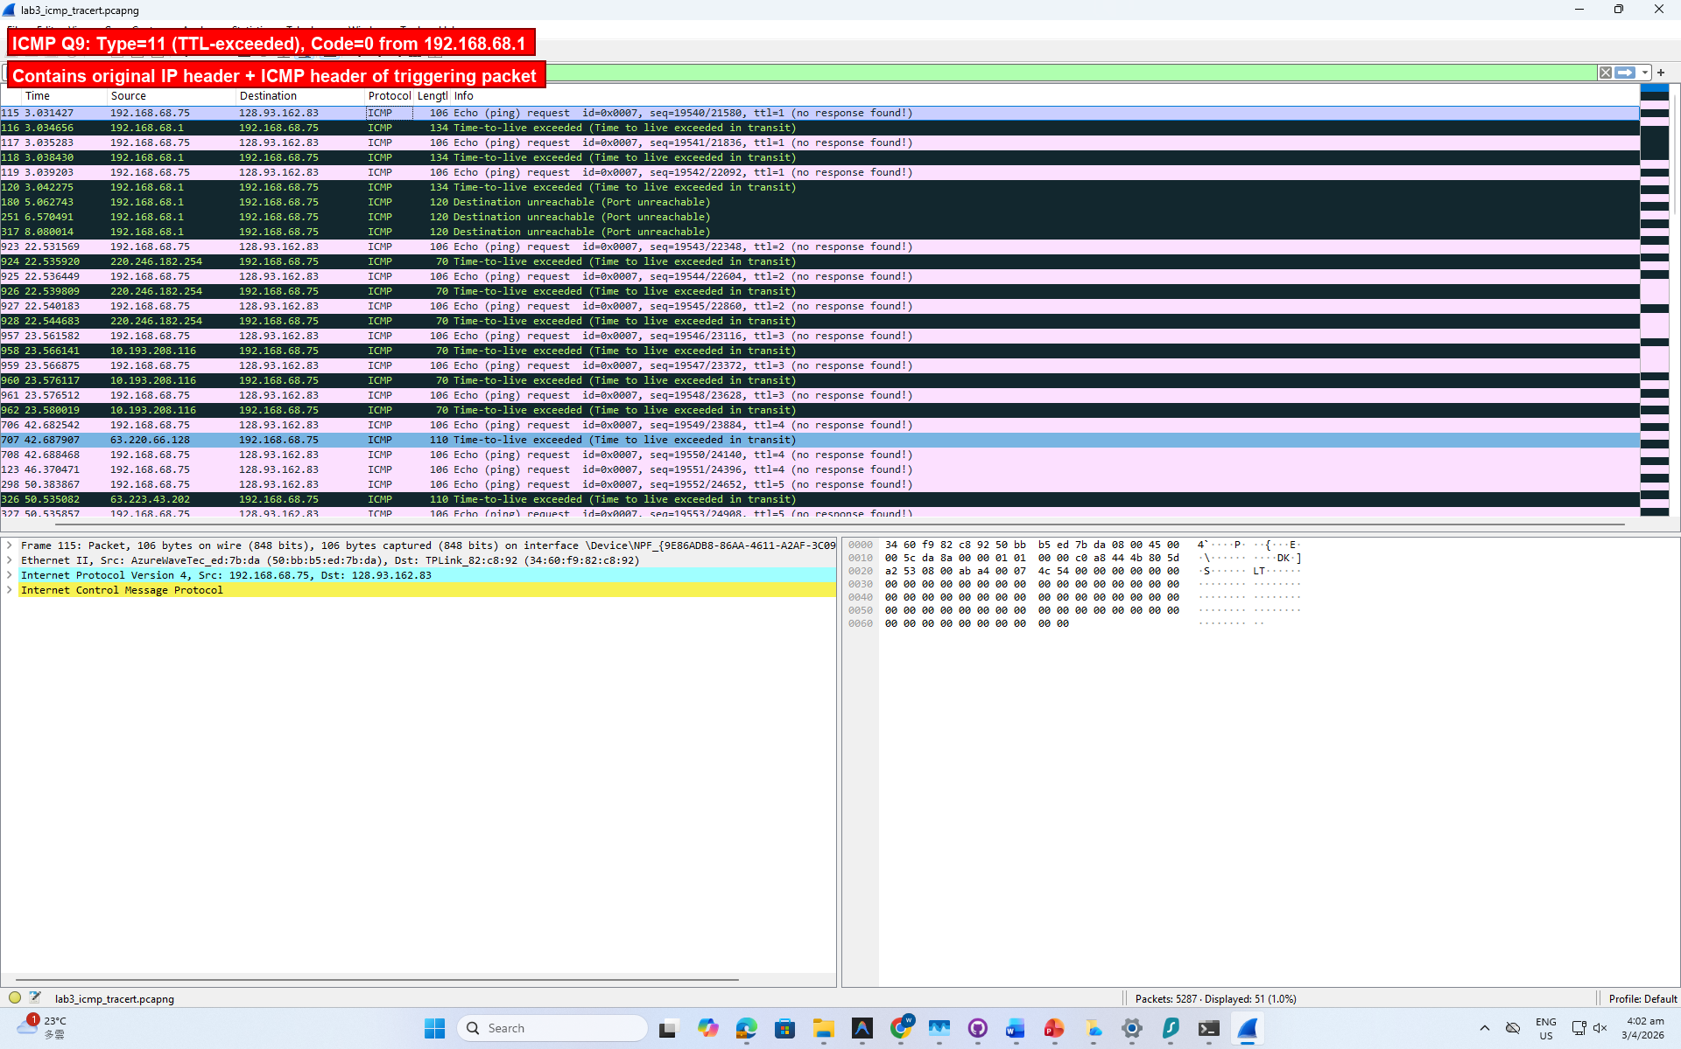
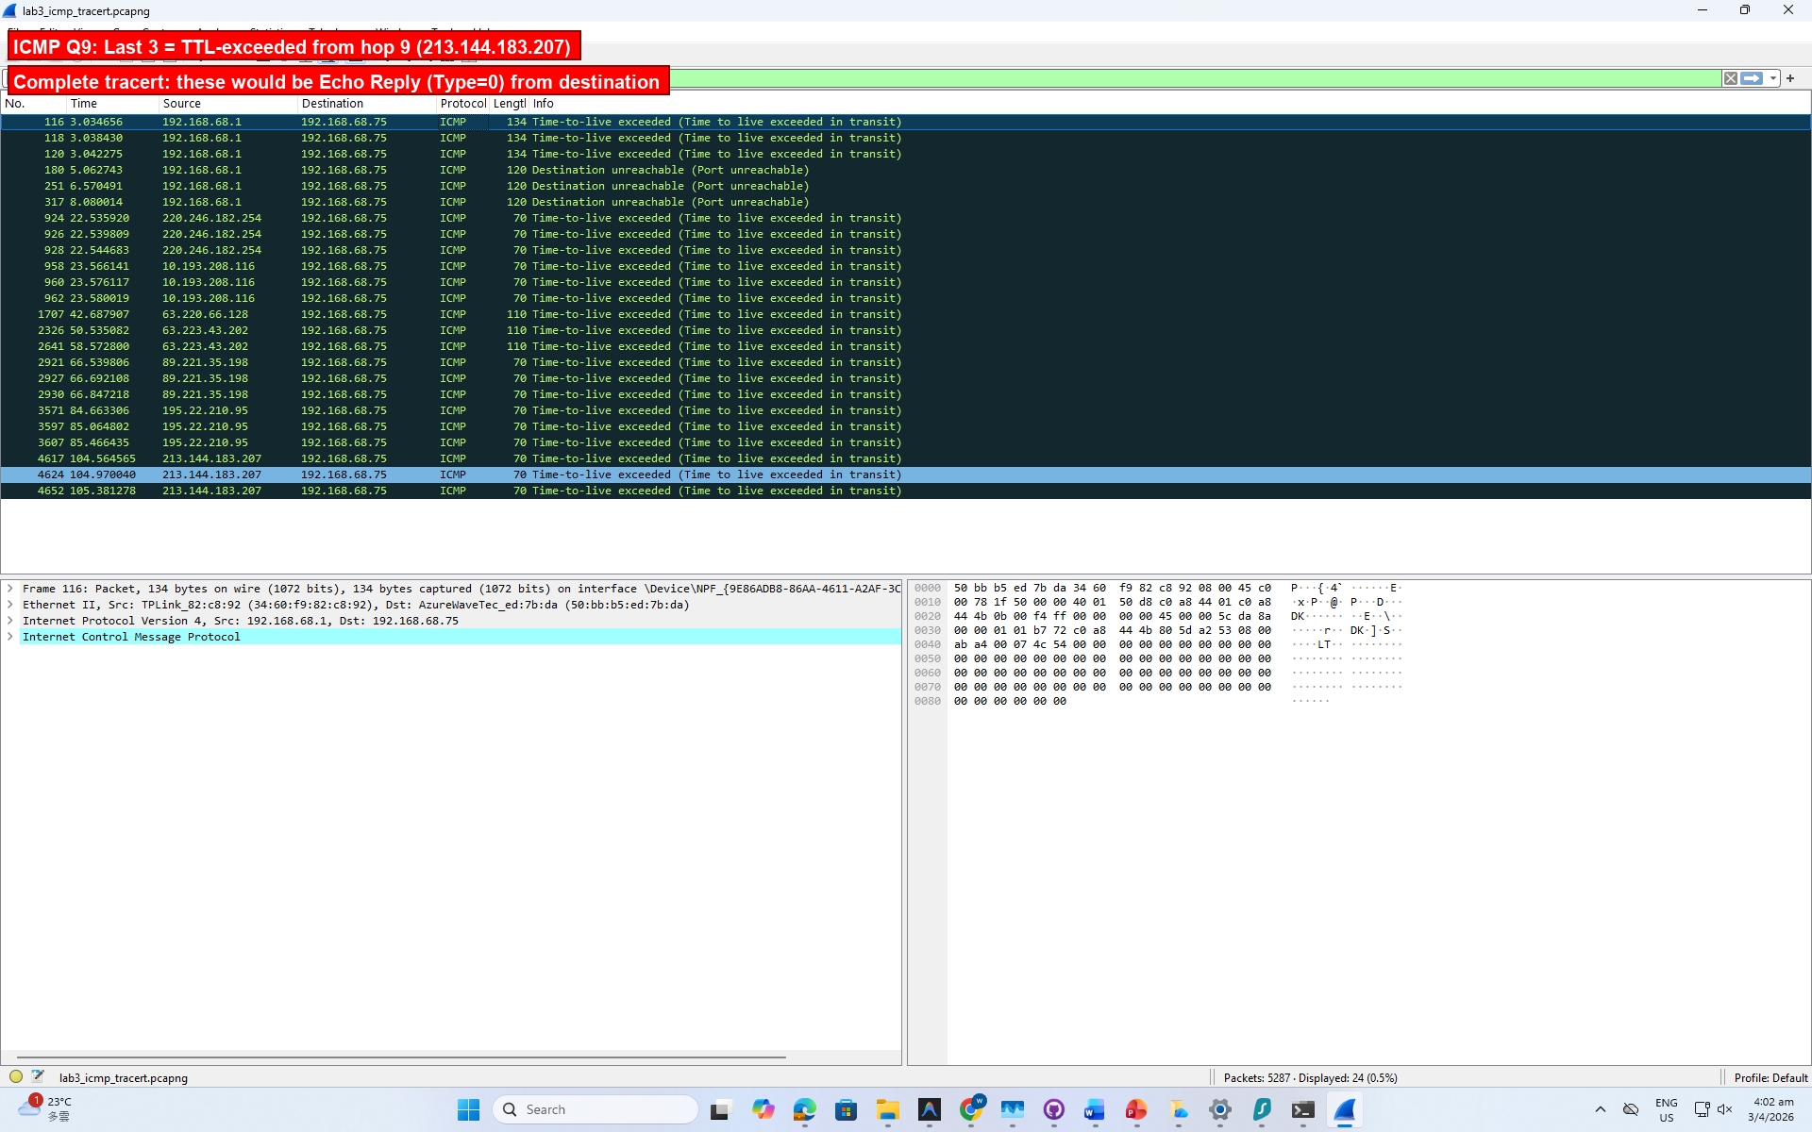
The last three ICMP packets received are TTL-exceeded (Type 11, Code 0) messages from the 9th hop router (213.144.183.207). In our trace, the tracert to www.inria.fr did not fully complete.
In a complete tracert, the last three packets would be Echo Reply (Type 0, Code 0) from the destination host (128.93.162.83) rather than TTL-exceeded errors from intermediate routers.
Key differences between Echo Reply and TTL-exceeded:
1. Type: Echo Reply = Type 0; TTL-exceeded = Type 11
2. Source IP: Echo Reply comes from the destination; TTL-exceeded comes from intermediate routers
3. Payload: TTL-exceeded packets contain the original IP header + first 8 bytes of the triggering packet (encapsulated). Echo Reply simply echoes back the original data.
4. Why different: The last-hop probes reach the destination without TTL expiring, so the destination responds with an Echo Reply instead of a router dropping the packet.

